**HOW I SPENT MONEY FOR THE LAST 20 MONTHS**

Introduction

Money has always been on my mind but for most of my life I saved a lot more than I spent. It wasn’t until I was in college when the opposite turned true. Before going on, I need to define what “spending” is relative to this post. I tried to focus on purchases where I had the choice to buy or not to buy. Anything I got for free was also not recorded. For example, my tuition is not being included, thank you Mom and Dad.

Why am I tracking my spending?

October 2014, I decided to track my spending for two main reasons. The first reason, I wanted to minimize my spending because most of my income was coming from my parents. I was also living off-campus so I had more freedom to decide what I had to spend money on. For example, purchasing a meal plan was required by the school for students who wanted to live on campus while someone living off campus could choose to buy groceries in whatever quantity. The second reason, I wanted to see how I spent money. I wanted to know what I was buying, and how often I was spending.

The categories

I organized my expenses into 6 categories.

* **Asset**: Anything that had a useful life. Includes luxury and necessary things. Examples would be pens, clothes, computer parts, repair expenses, software subscriptions, etc.
* **Bill**: Bills for water, electricity, internet, etc. that I paid while in college.
* **Entertainment**: Purchases that were consumed instantly. Examples include movie tickets, entry fees, pool hall rates.
* **Food**: Includes groceries, eating at a restaurant, tips. Does not include things necessary to eat like buying a fork would go under the Asset category.
* **Other**: Any time I spent my money for someone else. Example, gifts that I purchased but also includes expenses that did not fall into the other categories.
* **Transportation**: Any cost related to moving from one place to another. This includes gasoline, public transit fares. Things like car repairs would fall into the Asset category.

*Sales tax would be associated with the category of the purchase.

The data

An example of an entry.

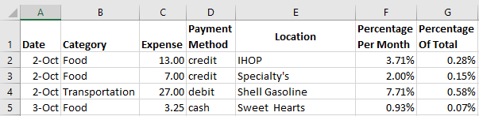

\**Percentage Per Month (PPM)* is the weight a purchase relative to the month’s total. *Percentage of Total (PoT)* is the weight of a purchase relative to the year’s total. Example, if I spent $100 total in January then a $10 purchase in January would have a PPM of 10%. If I spent $1000 in that year, then that $10 purchase would have a PoT of 1%.

I also tracked running totals by month, year, and category.

A snippet of monthly totals:

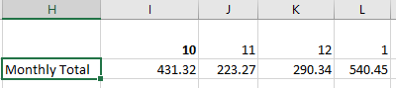

Totals by category and by year:

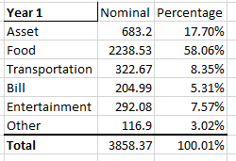 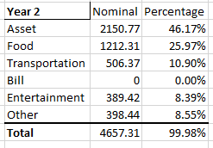

Oct 2014 – Sep 2015 (12 months) Oct 2015 – May 2016 (8 Months)

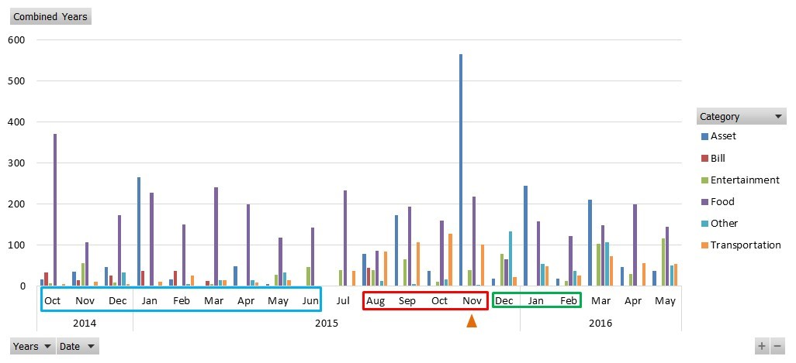

Here is a bar graph which breaks down my spending into categories and months. October 2014 to Jun 2015, indicated with the light blue box, I was finishing my last year of university. From August 2015 to November 2015 I was working and being paid, indicated with a red box. In November 2015, indicated by the orange triangle, I bought a bicycle for $977. For this analysis I decided to exclude it from the graph and the next calculations because it was a very special and rare purchase. It is, however, included above in my totals. The green box from December 2015 to February 2016 indicates when I was working for a start-up but not being paid. These 3 stages had a huge influence on my spending habits, but because of the huge differences in time lengths I am going to draw my conclusion with the 3 stages in the back of my mind.

During these 20 months, I made 640 different purchases. I want to focus on the Asset, Entertainment, and Food categories because purchases under these categories really depended on whether I wanted to buy or not to buy, and no other factors.

*November 2015 excludes $977 bicycle purchase.

Things I have noticed:

I’m starting with what I found to be the least interesting, just to get them out of the way.

1. After working, I started spending a lot more money on assets and entertainment. Pretty self-explanatory.
2. Monthly food expenses nearly stayed within a single deviation of the monthly mean with only 3 major exceptions: Oct 2014, Aug 2015, and Dec 2015. In Oct 2014 I purchased an upfront school meal plan so that I wouldn’t have to worry about food during finals. I’m not sure why August 2015 food expenses were so low but I am guessing that is when a couple snacks from the company kitchen was good enough for me. For Dec 2015, I was home for the holidays and had plenty of opportunities to eat some free food.
3. Monthly spending in these 3 categories fluctuated month by month. Starting from the beginning, Oct 2014 was a medium spending month which was followed by two low spending months. Jan 2015 was a high spending month which was followed by low spending, and so on. In other words, my spending is very cyclical.
4. When comparing months with nearly identical monthly spending, example Mar 2015 and Apr 2015, the parts of the sum are quite different. For these two months, there was a difference of about $2 but $50 of April’s spending went from Food to Asset. Another example, Aug 2015 and Oct 2015, there was a difference of about $5 but August’s food expense doubles October’s. The difference was closed because I had spent more in Assets and Entertainment for August.

Did I achieve my goals?

Was I able to minimize my spending while I was a student?

This is a hard question for me to answer. I limited my spending to mostly food but $200 a month is a lot to me. Especially since most of the time I was buying campus food, which is more expensive, in order to save time because I relied on buses.

What was I buying?

As a student, food was my main concern. When I was working, food expenses stayed the same but with the extra income I was spending more on other things. I was also more willing to spend on others.

How often was I spending?

My spending seems to follow a seasonal cycle. Though, it is hard say since I went from being a student to a paid employee to a job seeker during these 20 months.

Was this project worth doing?

After 20 months, I think this is just the beginning of this “experiment”. (Hopefully) I am in a very transitional point in my life so I don’t expect this data to be able to predict my future spending. It will also need to be modified once I start thinking about retirement and other things. I don’t think I have revealed any mysteries on how I manage my money. If anything this project has been more of a diary of the last 20 months.

One drawback of this project, I think I conditioned myself to spend under a budget. Initially I just wanted to see how I spent money. Once I started keeping track I would think about how much I’ve spent and aim for targets. On multiple occasions I would not spend money because I knew I was pushing $300 for a specific month, or I would let myself buy something because I only spent $100 halfway through the month.

Thanks for reading and if you have any questions or advice, I’d love to hear them.